Assignment -1

1.8-3 For a particular gaseous system, it has been determined that the energy is given by

U = 2.5PV + constant

The system is initially in the state P = 0.2 MPa (mega-Pascals), V = 0.01 m3; designated as point A in the figure. The system is taken through the cycle of three processes as follow:

(A B, B C, and C A) shown in the figure.

Calculate Q and W for each of the three processes. Calculate Q and W for a process from A to B along the parabola P = 105 + 109*(V - .02)2•

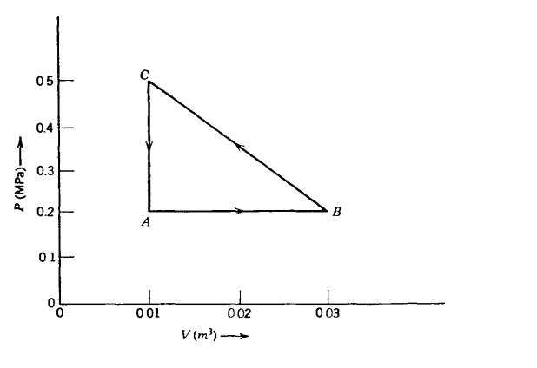

1.8-4 For the system of Problem 1.8-3 find the equation of the adiabats in the P- V plane (i.e., find the form of the curves P = P(V) such that dQ = 0 along the curves).

1.8-7 Two moles of a particular single-component system are found to have a dependence of internal energy U on pressure and volume given by

U = APV2 (for N = 2)

Note that doubling the system doubles the volume, energy, and mole number, but leaves the pressure unaltered. Write the complete dependence of U on P, V, and N for arbitrary mole number.

1.10-1f) The following ten equations are purported to be fundamental equations of various thermodynamic systems. However, five are inconsistent with one or more of postulates II, III, and IV and consequently are not physically acceptable. In each case qualitatively sketch the fundamental relationship between S and U (with N and V constant). Find the following equation is whether physically permissible or not and indicate the postulates violated by each. The quantities $v_{0}$, θ, and R are positive constants, and in all cases in which fractional exponents appear only the real positive root is to be taken.

$$S=NRln\left(\frac{UV}{N^{2}Rθv_{0}}\right)$$

1.10-3 The fundamental equation of system A is

$$S={\left(\frac{R^{2}}{v_{0}θ}\right)}^{1/3}{\left(NVU\right)}^{1/3}$$

and similarly for system B. The two systems are separated by a rigid, impermeable, adiabatic wall. System A has a volume of 9 × 10-6 m3 and a mole number of 3 moles. System B has a volume of 4 × 10-6 m3 and a mole number of 2 moles. The total energy of the composite system is 80 J. Plot the entropy as a function of $\frac{U_{A}}{(U_{A}+U_{B})}$ If the internal wall is now made diathermal and the system is allowed to come to equilibrium, what are the internal energies of each of the individual systems? (As in Problem 1.10-1, the quantities $v_{0}, θ$ and R are positive constants.)

2.2-1. find the equations of state for a system with the fundamental equation

$$U =\frac{\left(\frac{v_{0}θ}{R^{2}} \right)S^{3}}{NV}$$

Corroborate that the equations of state are homogenous zero order (i.e, that T,P and $μ$ are intensive parameters).

2.28. Show that , in analogy with equation 2.25,for a system with r components

$$du=Tds-Pdv+\sum_{j=1}^{r-1}{\left(μ_{j}-μ_{r}\right)dx_{j}}$$

Where the $x_{j}$ are the mole fractions $\left(=\frac{N_{j}}{N}\right)$

2.6-3. Two particular system have the following equations of state:

$$\frac{1}{T^{(1)}}=\frac{3}{2}R\frac{N^{(1)}}{U^{(1)}}$$

$$\frac{1}{T^{(2)}}=\frac{5}{2}R\frac{N^{(2)}}{U^{(2)}}$$

Where R is the gas constant (problem 2.6-2). The mole number of the first system is N(1) =2 and that of the second is N(2) =3. The two system are separated by a diathermal wall, the total energy in the composite system is 2.5*103 J. what is the internal energy of each system in equilibrium?

2.7.1 Three cylinders are fitted with four pistons. as shown in Fig. 2.2. The cross-sectional areas of the cylinders are in the ratio A1: A2: A3 = 1:2:3. Pairs of pistons are coupled so that their displacements (linear motions) are equal. The walls of the cylinders are diathermal and are connected by a heat conducting bar (crosshatched in the figure). The entire system is isolated (so that, for instance, there is no pressure exerted on the outer surfaces of the pistons). Find the ratios of pressures in the three cylinders.

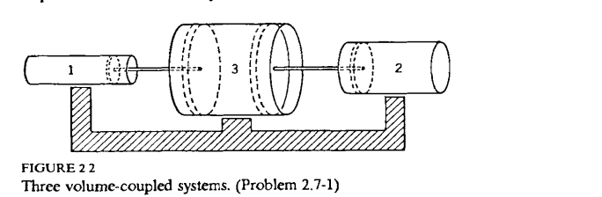

2.8-1 The fundamental equation of a particular type of two-component system is

$$S=NA+NR\ln{\frac{U^{3/2}V}{N^{5/2}}}-N_{1}Rln\frac{N_{1}}{N}-N_{2}Rln\frac{N_{2}}{N}$$

$$N=N_{1}+N_{2}$$

where A is an unspecified constant. A closed rigid cylinder of total volume 10 liters is divided into two chambers of equal volume by a diathermal rigid membrane, permeable to the first component but impermeable to the second. In one chamber is placed a sample of the system with original parameters $N_{1}^{(1)}=0.5 { , N}_{2}^{(1)}=0.75$, $V^{(1)}=5$ liters, and $T^{(1)}$ = 300 K. In the second chamber is placed a sample with original parameters $N_{2}^{(1)}=1 { , N}_{2}^{(2)}=0.5$, $V^{(2)}=5$ liters, and $T^{(2)}$ = 250 K. After equilibrium is established, what are the values of $N_{1}^{(1)}, N_{1}^{(2)}, T, P^{(1)} and P^{(2)}?$